J. Eur. Orch.  50 (x): 501 – 5XX. 2018. | 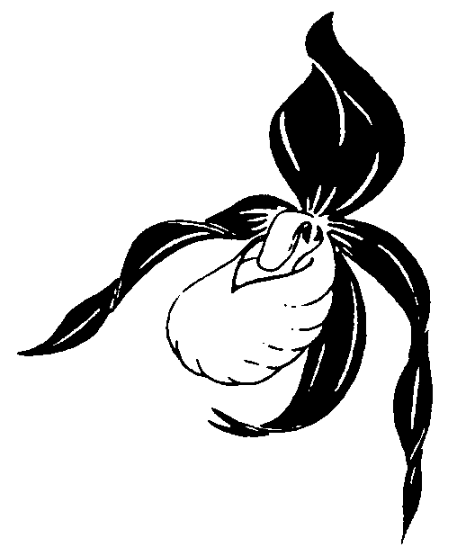

Full first name last name of author/s (Times New Roman 14 p)

Title (16,5 p) (preferably not longer than 2 lines)

Keywords
(in English) e.g.: Orchidaceae; Orchis .......; distribution; ecology; endangerment; protection.

Summary
Last name, F. (2018): Title (in English).- J. Eur. Orch. 50 (x): 501-5XX.
Please give brief summary (in English).

Zusammenfassung
Familienname, F. (2018): Titel/title (in Deutsch/German).- J. Eur. Orch. 50 (x): 501-5XX.
Brief summary in German (authors not familiar with German may deliver an English summary to be translated by JEO-redaction).
In case of contributions in third languages other than German/English please give enlarged summary (authors not familiar with German may deliver an enlarged English summary to be translated by JEO-redaction).

Riassunto – Résumé – Resumen – Резюме – Περίληψη - ...(as free option, if wished by the author)
Last name, F. (2018): Title (in third language).- J. Eur. Orch. 50 (x): 501-5XX.
Please give brief summary (in third language).

* * *

1. Introduction

2. Materials/Methods

3. Results etc.

x. Discussion

Acknowledgments

Bibliography (cited titles only, e.g.)

Arbeitskreise Heimische Orchideen (Hrsg.) (2005): Die Orchideen Deutschlands.- Uhlstädt-Kirchhasel.
Ayasse, M., Paxton, R. & J. Tengö (2001): Mating behaviour and chemical communication in the order Hymenoptera.- Annual Review of Entomology 46: 31–78.
Bateman, R.M., Hollingsworth, P.M., Preston, J., Yi-Bo, L., A.M. Pridgeon & M.W. Chase (2003): Molecular phylogenetics of the Orchidinae and selected ‘Habenariinae’ (Orchidaceae).- Bot. J. Linn. Soc. 142: 1–40.
Baumann, H. (2005): Platanthera bifolia (L.) Rich.- In: Arbeitskreise Heimische Orchideen [Hrsg.]: Die Orchideen Deutschlands: 647-649, 652.- Uhlstädt-Kirchhasel.
Delforge, P. (1994): Guide des Orchidées d’Europe, d’Afrique du Nord et du Proche-Orient.- Lausanne et Paris.
Delforge, P. (1992): Contribution à l’étude de trois espèces d’Ophrys récemment décrites: Ophrys cephalonica, Ophrys herae et Ophrys minoa (Orchidaceae).- Natural. belges 73 (Orchid. 5): 71-105.
Europäische Kommission, GD XI (1996): Interpretation manual of European Union Habitats, Version eur 15 (compiled by Româo, C.).- Bruxelles.
Faurholdt, N. (2003): Zur Verbreitung von Ophrys holoserica (Burm. f.) Greuter subsp. oxyrrhynchos (Tod.) H. Sundermann auf dem süditalienischen Festland.- Ber. Arbeitskrs. Heim. Orchid. 19 (2): 27-32. "2002".
Kreh, U. (2002): 28 Stammberg.- In: Wolf, R. (Hrsg.): Die Naturschutzgebiete im Regierungsbezirk Stuttgart.- Bezirksstelle für Naturschutz und Landschaftspflege Stuttgart: 340-343.- Stuttgart.
Künkele, S. & H. Baumann (1998): Orchidaceae.- In: Sebald, O., Seybold, S., Philippi, G. & A. Wörz: Die Farn- und Blütenpflanzen Baden-Württembergs, Vol. 8: 286-462.- Stuttgart.
Moore, D.M. (1980) Chamorchis Rich. In: Tutin, T.G., Heywood, V.H., Burgess, N.A., Moore, D.M., Valentine, D.H., Walters, S.M. & D.A. Webb (eds.) Flora Europaea 5. Alismataceae to Orchidaceae: 332.- Cambridge University Press, Cambridge.
Pedersen, H. Æ. & N. Faurholdt (2007): Ophrys – The bee orchids of Europe.- Kew Publishing, Royal Botanic Gardens, Kew.
Perazza, G. (2010): Epipactis helleborine subsp. moratoria Riech. & Zirnsack, orchidea nuova per l´Italia.- GIROS Notizie 44: 50-52, Inserto 3.
Reinhard, H. R., Gölz, P., Peter, R. & H. Wildermuth (1990): Die Orchideen der Schweiz und der angrenzenden Gebiete.- Egg.
Schmid, W. (1987): Orchideenkartierung in der Schweiz.- Mitt. Bl. Arbeitskr. Heim. Orch. Baden-Württ. 19 (3): 757-768.
Schmidt, V. M. (2005): Flora Arkhangelskoi oblasti (The flora of Archangelsk Region).- Saint-Petersburg.
Vöth, W. (2001): Orchideen und ihre Wespen und Bienen.- J. Eur. Orch. 33 (4): 1025-1052.

Internetquellen / Internet sites

Antonopoulos, Z.: Orchids of Greece (Hellas).- http://www.greekorchids.gr/ (accessed on 12 November 2012).
World Checklist of Selected Plant Families, Royal Botanic Gardens Kew.- http://apps.kew.org/wcsp/namedetail.do;jsessionid=C8574A18766C44DA904BD13EF47BC770?name_id=462243 (accessed on 12 November 2012).

Address of author/s

Hermine & Biene Hummel
Lehrpfad 12
D-69469 Ort /Town
Land / Country
E-Mail: name@domaine.xx

Colour marking to be deleted after completion of manuscript: corrections, proposals to change, annotations, i.e.:

yellow insertions to be checked green to be checked or emended

red to be deleted purple changed (format, position, ...)

grey our annotations turquoise to be completed by redaction

Tables (Arial, 11 – 12 p), graphics, diagrams, figures, coloured tables with captions, either as appendix or, to a limited extent, within the text. Material provenance, applied methods, physic. units; e.g. UTM_{WGS84} – coordinates, altitude (m asl) should be indicated.

Captions of plant figures should contain botanical name, provenance (country, region, locality, pref. UTM-coordinates, altitude m asl, date, author) e.g.:

Fig. 1: Orchis militaris, Germany, Baden-Württemberg, Weinheim, 32U 0476248 5490857, 245 m asl, 13.5.2002 (phot. name or initials of the author).
Fig. 2: Orchis militaris, .....
Fig. x: Orchis militaris, .....

Examples for colour plates with 1 to 9 (12) figures, captions separately:

1 | 2
 | 3
4 | 5

6 | 7
8 | 9
10 | 11

12 | 13
14 | 15

1 | 2
 | 3
4
 | 5

16 | 17 | 18
19 | 20 | 21
22 | 23 | 24

16 | 17 | 18
19 | 20 | 21
22 | 23 | 24

Abb. 1: Orchis militaris, ....
Fig. 1: Orchis militaris, ....

Abb. 1: Orchis militaris, ....
Fig. 1: Orchis militaris, ....
Abb. 1: Orchis militaris, ....
Fig. 1: Orchis militaris, ....

Abb. xx:

Abb. xx:

Abb. 1: Orchis militaris, .... | Fig. 1: Orchis militaris, ....
Abb. 1: Orchis militaris, .... | Fig. 1: Orchis militaris, ....

Fig. 1:.Legende / captions / didascalia

Fig. 3:

Fig. 20:

